Using finally block immediately after the try block

We can write the ***finally***block immediately after the ***try***block by skipping the ***catch***block.  
  
Syntax -  
  
try {  
         //Code inside the try block  
}  
  
finally {  
        //Code inside the finally block  
}  
  
Lets implement this on Eclipse IDE -  
  
1. Launch Eclipse IDE, create a new Java Class 'FinallyDemo3.java' with main( ) method in the existing Java Project 'Project 46' as shown below -

[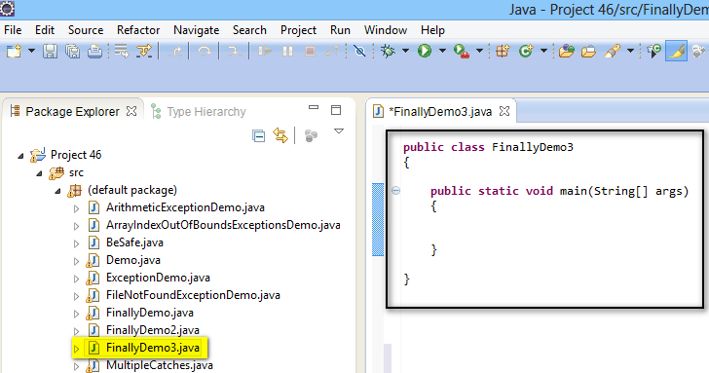](https://1.bp.blogspot.com/-HkN8bct_5DM/U_NEf5iVxcI/AAAAAAAAcAo/c7mbiQ3SJIQ/s1600/1.jpg)

2. Create a try block and write a statement which prints "I am in try block" text as shown below -

[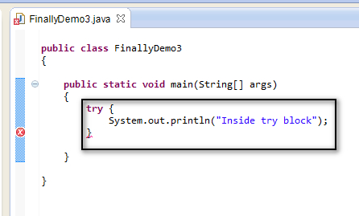](https://2.bp.blogspot.com/-so6chJLf0FY/U_NGHtVhCUI/AAAAAAAAcAw/Z8fNGjcM11Q/s1600/2.jpg)

3. Create a finally block without creating catch block and write a statement which prints "I am in finally block" text as shown below -

[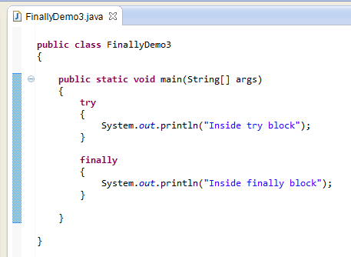](https://4.bp.blogspot.com/-VWuqkqxfwqk/U_NGiQjC4QI/AAAAAAAAcA4/-zq4QshKCOs/s1600/3.jpg)

4. Save and Run the Java class 'FinallyDemo3.java' and observe that the statements in the try block and finally block got executed and the output is displayed as shown below -

[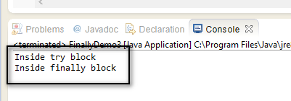](https://1.bp.blogspot.com/-517VDHVlO_s/U_NG1bfUF9I/AAAAAAAAcBA/XeOEp9IpSI8/s1600/4.jpg)

Hence ***finally***block can be written immediately after the ***try***block.